

American International University- Bangladesh

**Course:** Computer Graphics

**Section:** A

**Project title:** Air Water Solar Energy Plant

**Group Member List:**

|  |  |  |  |  |
| --- | --- | --- | --- | --- |
| **Name** |  | **ID** | **Contribution** | **Sign** |
| 1. AHMED, MUNIM | 20-43303-1 |  | 25% | Munim |
| 2. MAHMUD, MIRZA ASIF | 20-43314-1 |  | 23% | Asif |
| 3. FUAD, ARAFAT AL KHAIR | 20-43607-1 |  | 22% | Fuad |
| 4. JOYA, NABILA CHOWDHURY | 20-42268-1 |  | 15% | Joya |
| 5. RIFAT, MOSA. UMME RUMAN | 20-42936-1 |  | 15% | Rifat |

**Contributors:**

1. AHMED, MUNIM (20-43303-1) – Animation, Sound and Project Co-ordination
2. MAHMUD, MIRZA ASIF (20-43314-1) – Rain, Night, Day and Still Image Draw (Cloud, Sun, Road, River, Tree)
3. FUAD, ARAFAT AL KHAIR (20-43607-1) – Still Image Draw (Windmill, Tower, Tunnel, PowerStation, Solar Panel)
4. JOYA, NABILA CHOWDHURY (20-42268-1) – Still Image Draw- (Car, Truck, Boat, Plane, Tunnel)
5. RIFAT, MOSA. UMME RUMAN (20-42936-1) – Graph Paper Point Placement

**Supervised By**

MAHFUJUR RAHMAN

# Introduction

We may not even be aware of the availability of energy resources in our natural environment. However, certain natural resources have been utilized for mankind and transformed into useful energy over the previous few decades. The project provides a practical example of how renewable energy sources, such as wind, water, solar power, etc., can be used to generate electricity for developing nations. Here, code blocks act as an IDE and the Open Graphics Library is utilized to generate a variety of 2D objects from a real-world scenario.

# Problem Background

Bangladesh's 166 million residents still lack access to electricity, and the nation frequently uses only a small portion of its 11,500-megawatt generating capacity. As a result, those underdeveloped areas experience an electrical scarcity, particularly at night. Even their most basic electricity needs cannot be satisfied by the local population. When the candlelight runs out, the students are helpless because they must rely on it. Nighttime driving is dangerous because of the darkness that surrounds the roads.

A bike accident occurred at the Mawa Ghat Bridge on December 11, 2021, at midnight. The body's recovery from the center of the road presented the toughest problem of the occurrence. The villagers were unable to warn the cars crossing the bridge to slow down so they could remove the dead body from the middle of the road because there were no lights on either side of the bridge. Another example is that due to electricity problems, many crimes are happening on the Kuril flyover after mid-night nowadays. The main cause is that there is no lighting system on the bridge since Mawa Ghat has insufficient management and power. This is but one example. Due to inadequate lighting on highway bridges, a sizable number of individuals suffer injuries or pass away in car accidents each month.

We are proposing the "Air Water Solar Energy Plant" project to resolve these deadly issues. Its goal is to develop a realistic simulation using OpenGL for electricity generation using renewable energy sources like solar energy, wind energy, and water flow, as well as to satisfy demand in some areas where electricity is not yet available.

# Objective

This project's main goal is to show how to utilize the natural resources in Bangladesh's undeveloped regions. Through a demonstration model of computer graphics, we can suggest potential solutions, apply animations for moving objects, include different modes for scenarios, and finally implement keyboard control and sound effects to resolve the deadly issues mentioned above where we can use these natural resources to meet the power deficit.

# Methodology

In this project we have implemented three scenarios, 20 object functions, 3 display functions, 10 animation functions, 3 sound functions, 2 mouse and keyboard functions, 5 function for translations and 5 drawing functions so far. They are-

|  |  |
| --- | --- |
| Object Functions | Cloud() |
| Lamppost_Panelroad() |
| lowerRiverSide() |
| Tunnel() |
| Turbine() |
| Windmill() |
| Bluecar() |
| Building() |
| Bus() |
| Car() |
| Star() |
| Thunder()   |  | | --- | | Rain_cloud(); | | Storm_cloud(); | | Tunnel_upperside(); | | Tower(); | | Tree(); | | trafficLight(); | | Ship(); | | Sun_moon(); | |
| Display Functions | |  | | --- | | displayDay() -- int val=1 | | displayNight() -- int val=9 | | displayRain() -- int val=5 | |
| Animation Functions | |  | | --- | | animation_car1() – (Function for bus) | | animation_ship1() – (Function for smoke) | | animation_ship2() – (Function for ship2) | | animation_waves() – (Function for wave) | | blade_translation() – for Turbine’s blade rotating | | doFrame() – for Windmill transition | | Cloud_animation() – for cloud animation | | RainAnimation() – for rain fall animation | | updateCar() – for upper road car animation | | updateTruck() – for truck animation | |
| Sound Functions | |  | | --- | | soundDay() -- sound of ship, car | | soundNull() | | soundRain() -- sound of rain | |
| Mouse and keyboard functions | |  | | --- | | handleKeypress() | | handleMouse() | |
| Function for translation | |  | | --- | | Gltranslate() | | Glscaling() | | Glrotate () | | glPushMatrix() | | glPopMatrix() | |
| Drawing Functions | |  | | --- | | GL_TRIANGLES | | GL_LINES | | GL_POLYGON | | GL_QUADS | | glColor3f() | |
| Views | Day |
| Night |
|  | Rain |

For “Day” display, the base background is kept white. Then, sky (), cloud () and sun () functions are called to create the environment of a sunny day in OpenGL. Afterwards, to add the hills at the very back of the display, hill () function is called. Similarly, other functions for instance, car (), river (), windmill (), tunnel () are called in a sequence to picturize the scenario in display. Different shapes (such as, triangles, squares, polygons, circles etc.) with regional colors are used to form the overall scenery.

* GL_TRIANGLES is used to form a triangle with 3 vertices in 2D shape.
* GL_LINES is used to create a line to particular end.
* GL_POLYGON is used for creating a polygon. A polygon is formed by specifying a series of vertices.
* GL_QUADS is used for creating a 4-vertex quadrilateral primitive.
* glColor3f() function which takes 3 parameter is used to color particular shape

As for animation, it has been applied to the moving objects that includes cars and clouds. However, we also intend to add animation feature for rainy weather and boats.

To create animation like effect glTranslatef () function is used. It receives three parameters x, y, z and they specify the x, y, and z coordinates of a translation vector. The targeted objects is kept inside glPushMatrix () and glPopMatrix (). We further used glScalef () and glRotatef () to fix coordinates of the object shapes.

Finally, key controlling system is used to switch between “Day”, “Night” and “Rainy” mode.

# Significance of the project

The project's goal is to offer a potential solution for Bangladesh's poor areas' electricity shortage. The nation still has to make progress in this area and supply enough electricity to the entire nation. Implementing the suggested solutions in underserved areas can significantly reduce the need for electricity till that time.

* Setting up of windmill and turbine
* Installation of solar panels
* Installation of solar powered lights by roadside and bridge

Furthermore, the accidents that frequently occur on bridges at night, as well as many fatal incidents, can be avoided by the grace of solar powered light. 

# Conclusion

In conclusion, the "AWS Energy Plant" is developed using Code Blocks, an open-source Integrated Development Environment, and OpenGL. This project is designed for beginners and uses only 2D items. The scenario can be improved in a variety of ways to make it more precise and realistic. Better animation effects could be used in the scenario of a thunder storm in future iterations. The use of 3D effects, shading, or projection techniques can enhance the realism of the cars and hills. Overall, although being a beginner-level project, it accomplishes its goals of offering a technical solution to deal with the electricity issue in Bangladesh's undeveloped areas and finding a solution to the problem of frequent nighttime bridge accidents.

# Referencing

[1] M. Rahman, J. (2010). Power Crisis and Solution in Bangladesh, “*Bangladesh Journal of Scientific and Industrial Research”*

*Source:* <https://www.banglajol.info/index.php/BJSIR/article/view/5714>

[2] Dhaka Tribune (2021) Source: <https://www.dhakatribune.com/bangladesh/nation/2021/12/11/2-dead-as-truck-hits-bike-in-Mawa>

# Screenshot of the system

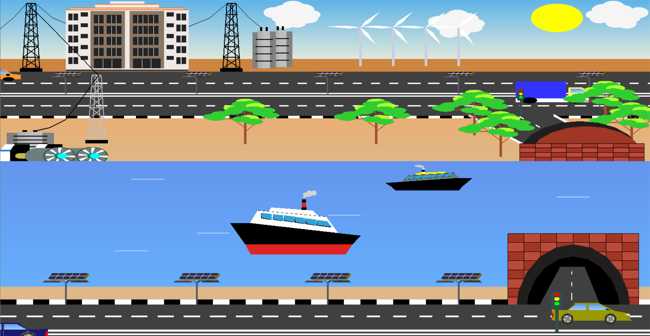

*Image 1.1: Day time scenario*

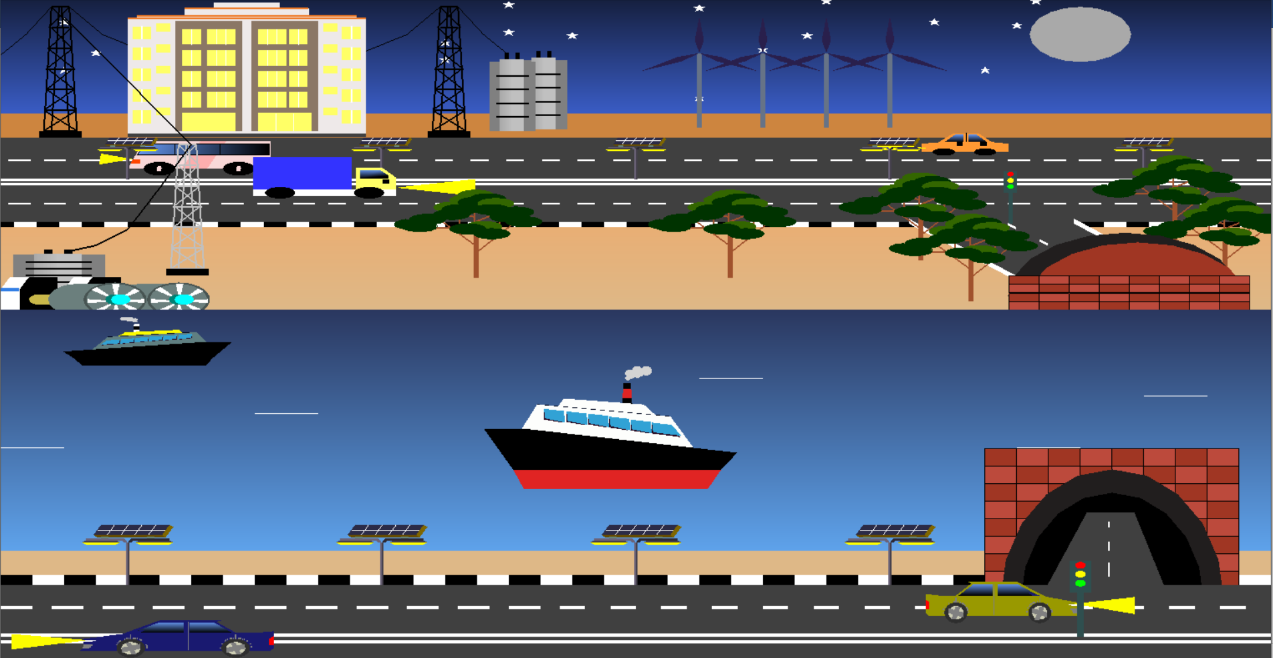

*Image 1.2: Night time scenario*

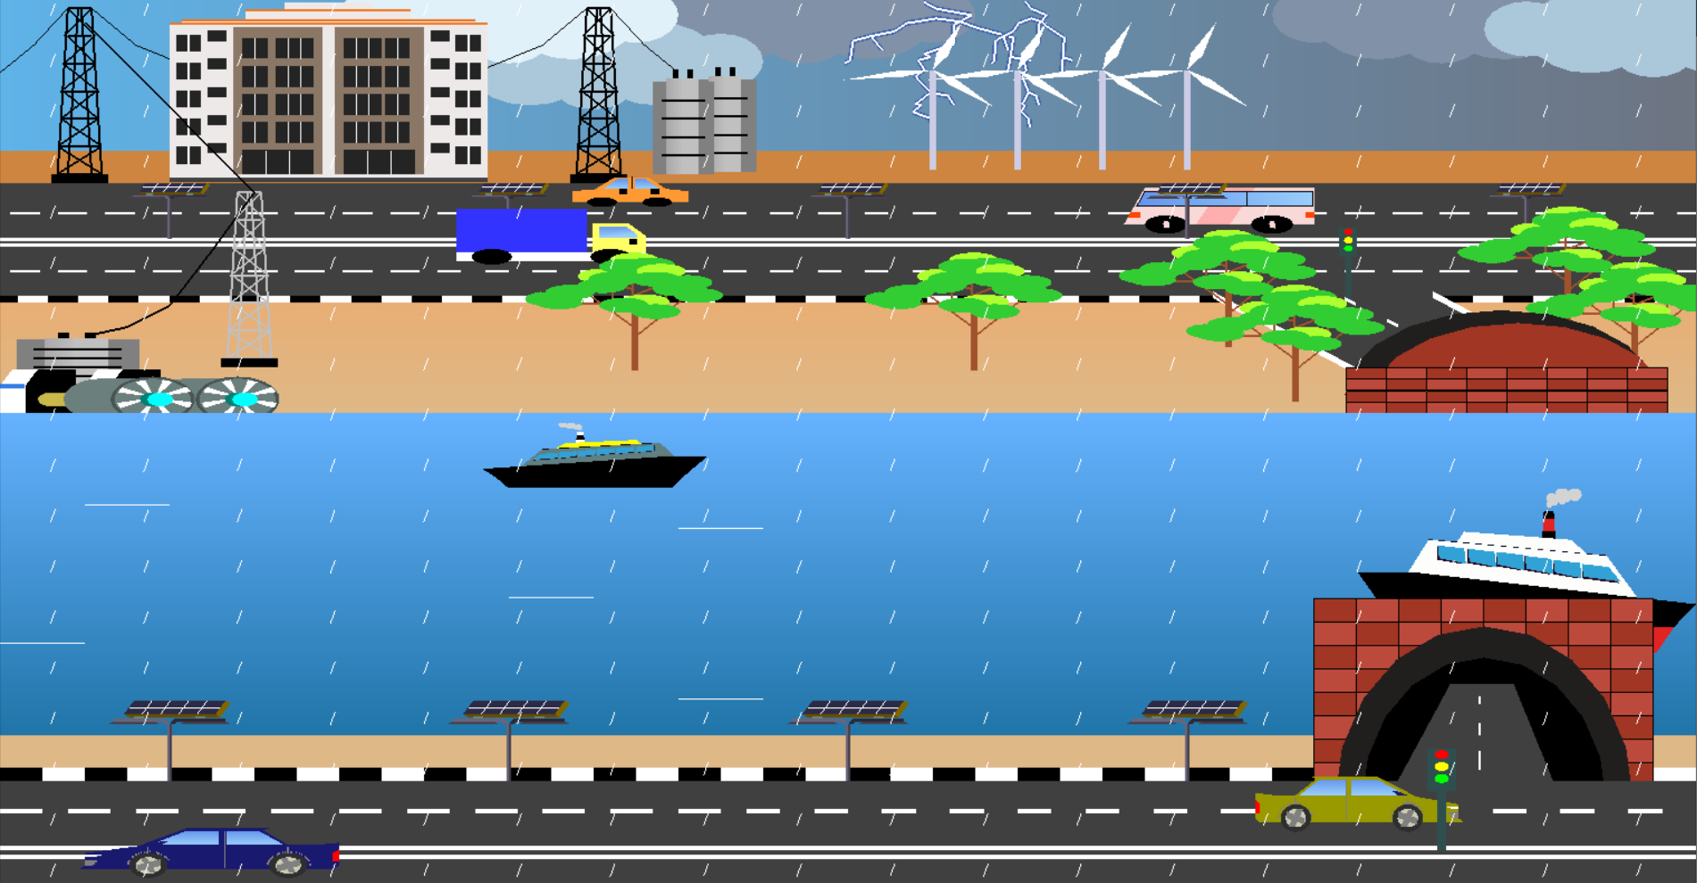

*Image 1.3: Rain time scenario*